

**PROJECT**

**S2J Apartemnet**

Author:

1. Julius Danes Nugroho (1710010190)
2. Jofanto Alfaj (1710010189)
3. Shafira Az'zahra (1710010210)

Faculty : Musawarman, S.Kom

Semester : 1

Quarter : 2

Class : 1NAP2

**CONTINUING EDUCATION PROGRAM CENTER**

**FOR COMPUTING AND INFORMATION**

**TECHNOLOGY FACULTY OF ENGINEERING**

**UNIVERSITY OF INDONESIA**

**2017**

# Table of Contents

Table of Contents i

PROJECT ON 1

S2J APARTEMENT 2

CERTIFICATE 3

ACKNOWLEDGEMENT 4

SYSTEM ANALYSIS 5

ENTITIES 6

TABLE DESIGN 7

TABLE DESIGN 8

SPECIAL FIELD PROPERTIESN 9

QUERY USED 10

FORM USED 11

REPORTS OUTLINE 12

E/R DIAGRAM 13

TABLES 14

PRIMARY AND FOREIGN KEYS 15

RELATIONSHIP BETWEEN FINAL TABLES 16

TABLE DESIGN 17

# PROJECT ON

Developed by

Group : 3

Name :

1. Julius Danes Nugroho (1710010190)
2. Jofanto Alfaj (1710010189)
3. Shafira Az'zahra (1710010210)

**NIIT**

**PROJECT ON**

*S2J Apartement*

# S2J APARTEMENT

Batch Code : 1NAP2

Start Date : November 17, 2017 End Date: December 4, 2017

Name of the Coordinator : Mr. Musawarman, S.Kom

Name of Developer :

1. Julius Danes Nugroho (1710010190)
2. Jofanto Alfaj (1710010189)
3. Shafira Az'zahra (1710010210)

Date of Submission : November 17, 2017

**S2J APARTEMENT**

(Project Title)

# CERTIFICATE

**CERTIFICATE**

This is to certify that this report titled S2J Apartement embodies the original work done by Julius Danes Nugroho, Jofanto Alfaj, and Shafira Az'zahra in partial fulfillment of their course requirement at NIIT.

Coordinator:

Mr. Musawarman, S.Kom

**NIIT**

# ACKNOWLEDGEMENT

Writer have benefited a lot from the feedback and suggestions given to us by Mr. Musawarman, S.Kom and other faculty members. Writer make this project to fulfill our assignment. Writer said Alhamdulillah to Allah S.W.T because of his blessing, writer can complete this project. Writer know this paper is far from perfection. Writer hope if writer friend and writer faculty give any comment and suggestion to make this paper better than before.

Writer also said thankyou to:

1. Our Family who give many support to make this paper completed.
2. Mr. Musawarman, S.Kom as the guide’s lecturer that give put together with the suggestion, idea, and constructive spirit to make this project better.
3. Our Friends who give many idea, spirit and comment to our project.

If the writer made a mistake in writing the application of this bookstore database. Writer ask forgive to all reader and listener of this paper.

Depok, 17 November 2017

Author

**ACKNOWLEDGEMENT**

# SYSTEM ANALYSIS

**System Summary:** The book store is a shop that sells books. The book sold is of the donations in the donors by the book donors and fund donors, and then in process through the staff.

**SYSTEM ANALYSIS**

# ENTITIES

**Number of entities:** 7

**Names of entities:**

1. CUSTOMER
2. BOOK
3. STAFF
4. BOOK DONORS
5. FUND DONORS
6. TRANSACTION
7. TRANSACTION DETAIL

**ENTITIES**

# TABLE DESIGN

**Database Name:** Bookstore Database System

|  |  |  |
| --- | --- | --- |
| BOOK | | |
| Field Name | Data Type | Description |
| Book_Code | Short Text | Code of Book (ISBN) |
| Book_Type | Short Text | Type of Book |
| Book_Titile | Short Text | Title of Book |
| Unit_Price | Number | The Price of The Book per One Unit |
| CUSTOMER | | |
| Field Name | Data Type | Description |
| Cust_Code | Short Text | Nomor Induk Kependudukan (NIK) |
| Cust_Name | Short Text | Name of Customer |
| STAFF | | |
| Field Name | Data Type | Description |
| Staff_ID | Short Text | Nomor Induk Pegawai (NIP) |
| Staff_Name | Short Text | Name of Staff |
| Position | Short Text | Position of Staff |
| BOOK_DONORS | | |
| Field Name | Data Type | Description |
| Book_Donors_ID | Short Text | Number ID of Book Donors |
| Book_Donors_Name | Short Text | Name of Book Donors |
| Book_Donors_Type | Short Text | Type of Book |
| Book_Donors_Quantity | Number | Some of The Books |
| Staff_ID | Short Text | Nomor Induk Pegawai (NIP) |
| FUND_DONORS | | |
| Field Name | Data Type | Description |
| Fund_Donors_Id | Short Text | Number ID of Fund Donors |
| Fund_Donors_Name | Short Text | Name of Fund Donors |
| Fund_Donors_Money | Currency | Many of The Money |
| Staff_ID | Short Text | Nomor Induk Pegawai (NIP) |

**TABLE DESIGN**

# TABLE DESIGN

**Database Name:** Bookstore Database System

|  |  |  |
| --- | --- | --- |
| TRANSACTION | | |
| Field Name | Data Type | Description |
| Transaction_ID | Short text | Number ID of Transaction |
| Cust_Name | Short Text | Name of Customer |
| Staff_Name | Short Text | Name of Staff |
| Book_Code | Short Text | Code of Book (ISBN) |
| Book_Type | Short Text | Type of Book |
| Book_Titile | Short Text | Title of Book |
| TRANSACTION DETAIL | | |
| Field Name | Data Type | Description |
| Transaction_ID | Short text | Number ID of Transaction |
| Book_Code | Short Text | Code of Book (ISBN) |
| Unit_Price | Number | The Price of One Book |
| Quantity | Number | Quantity of book |
| Total_Cost | Calculated | Total of Transaction |

**TABLE DESIGN**

# SPECIAL FIELD PROPERTIESN

**Database Name:** Bookstore Database System

|  |  |  |  |
| --- | --- | --- | --- |
| VALIDATION RULE | | | |
| Entities | Field Name | Value |
| BOOK | Book_Code | Like "BOOK[0-9][0-9][0-9]" |
| CUSTOMER | Cust_Code | Like "CUST[0-9][0-9][0-9]" |
| STAFF | Staff_ID | Like "STA[0-9][0-9][0-9]" |
| TRANSACTION | Transaction_ID | Like "TRA[0-9][0-9][0-9]" |
| TRANSACTION DETAIL | Transaction_ID | Like "TRA[0-9][0-9][0-9]" |
| VALIDATION TEXT | | | |
| Entities | Field Name | Value |
| BOOK | Book_Code | Sampel Input "BOOK010" ! |
| CUSTOMER | Cust_Code | Sampel Input "CUST010" ! |
| STAFF | Staff_ID | Sampel Input "STA010" ! |
| TRANSACTION | Transaction_ID | Sampel Input "TRA010" ! |
| TRANSACTION DETAIL | Transaction_ID | Sampel Input "TRA010" ! |
| INPUT MASK | | | |
| Entities | Field Name | Value |
| BOOK DONORS | Book_Donors_ID | "BKDNRS"000;;_ |
| FUND DONORS | Fund_Donors_ID | "FNDDNRS"000;;_ |
| CALCULATED | | | |
| Entities | Field Name | Value |
| TRANSACTION DETAIL | Total_Cost | =[quantity]*[unit_price] |

**SPECIAL FIELD PROPERTIES**

# QUERY USED

|  |  |  |  |
| --- | --- | --- | --- |
| Query Name | Query Type | Description | Tables/Queries Used |
| Query Book | Simple Query | This query describe about Book | Book Code, Book Type, Book Tittle, Unit Price |
| Query Customer | Simple Query | This query describe about Customer | Cust Code, Cust Name |
| Query Staff | Simple Query | This query describe about Staff | Staff ID, Staff Name, Staff Position |
| Query Transaction | Simple Query | This query describe about Transaction | Transaction ID, Cust Name, Staff Name, Book Code, Book Type, Book Tittle |
| Query Transaction Detail | Simple Query | This query describe about Transaction Detail | Transaction ID, Book Code, Book Type, Book Tittle, Unit Price, Quantity, Total Cost |

**QUERY USED**

# FORM USED

|  |  |  |  |
| --- | --- | --- | --- |
| Form Name | Form Type | Description | Tables/Reports Used |
| Main Menu | Columnar | This form describe about Main Menu | Book, Customer, Book Donors, Fund Donors, Staff, Transaction, Report Book, Report Customer, Report Book Donors, Report Fund Donors, Report Staff, Report Transaction, Report Transaction Detail |
| BOOK | Columnar | This form describe about Books | Book |
| CUSTOMER | Columnar | This form describe about Customer | Customer |
| BOOK DONORS | Columnar | This form describe about Book Donors | Book Donors |
| FUND DONORS | Columnar | This form describe about Fund Donors | Fund Donors |
| STAFF | Columnar | This form describe about Staff | Staff |
| TRANSACTION | Columnar | This form describe about Transaction | Transaction |
| TRANSACTION DETAIL Subform | Columnar | This subform describe about Detail Transaction | Transaction Detail |

**FORM USED**

# REPORTS OUTLINE

|  |  |  |  |
| --- | --- | --- | --- |
| Reports Name | Layout | Reports Type | Tables/Queries Used |
| Report BOOK | Columnar | Table | Book Code, Book Type, Book Tittle, Unit Price |
| Report CUSTOMER | Columnar | Table | Cust Code, Cust Name |
| Report BOOK DONORS | Columnar | Table | Book Donors ID, Book Donors Name, Book Donors Type, Book Donors Quantity, Staff ID |
| Report FUND DONORS | Columnar | Table | Fund Donors ID, Fund Donors Name, Staff ID |
| Report STAFF | Columnar | Table | Staff ID, Staff Name, Staff Position |
| Report TRANSACTION | Columnar | Form | Transaction ID, Cust Code, Cust Name, Staff Name, Staff ID, Staff Position |
| Report TRANSACTION DETAIL | Columnar | Query | Transaction ID, Book Code, Book Type, Book Tittle, Unit Price, Quantity, Total Cost |

**REPORTS OUTLINE**

# E/R DIAGRAM

**E/R DIAGRAM**

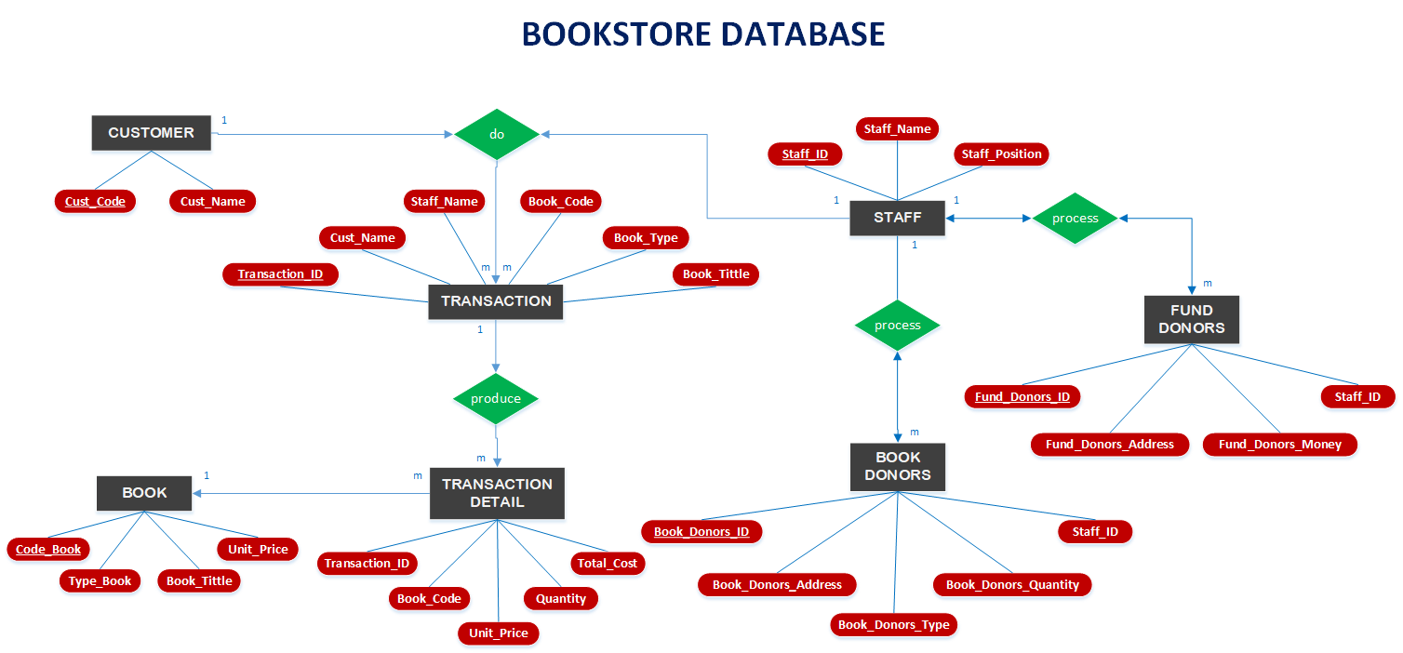

# TABLES

**TABLES**

**Number of Tables:** 7

**Structure of Tables:** The table structures are shown here



# PRIMARY AND FOREIGN KEYS

The Primary and Foreign keys (wherever applicable) for each table are listed with their respective table names:

* **BOOK**

*Primary key*: Book_Code

*Foreign keys*: -

* **CUSTOMER**

*Primary key*: Cust_Code

*Foreign keys*: -

* **STAFF**

*Primary key*: Staff_ID

*Foreign keys*: -

* **BOOK** **DONORS**

*Primary key*: Book_Donors_ID

*Foreign keys*: Staff_ID

* **FUND** **DONORS**

*Primary key*: Fund_Donors_ID

*Foreign keys*: Staff_ID

* **TRANSACTION**

*Primary key*: Transaction_ID

*Foreign keys*: Book_Code

* **TRANSACTION DETAIL**

*Primary key*: -

*Foreign keys*: Book_Code

**PRIMARY AND FOREIGN KEYS**

# RELATIONSHIP BETWEEN FINAL TABLES

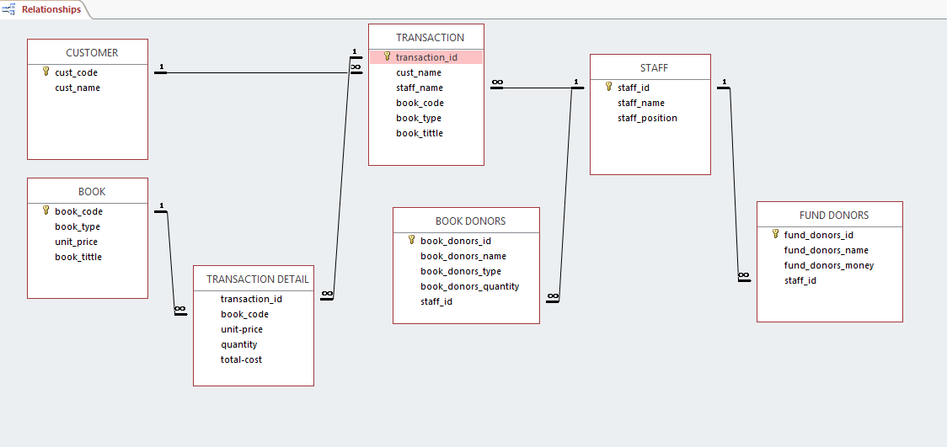

# TABLE DESIGN

**Hardware:** Laptop compatible with an Intel Core i3, 4 GB RAM, 64-bit Operating System, x64-based processor, and 500GB of Hard disk space

**Operating System:** Microsoft Windows 10 Home

**Software:** Microsoft Access 2016

|  |  |  |
| --- | --- | --- |
| PROJECT FILE DETAILS | | |
| S. No | File Name | Remarks |
| 1 | Bookstore System Database.accdb | Microsoft Office Access 2016 database that contains tables, queries, forms and reports |

**CONFIGURATION**